
FRANCISTOWN Cnr Haskins /Guy Street, near rail crossing. Central traffic and
northbound
BILLBOARD MEDIA
PROFILE

SITE REF: FT 41A
Plot 22995 Nkoyaphiri Industrial, Mogoditshane.
PO Box 1101, Gaborone
Tel: 392 4216 Mobile: 72 741 620
Email: info@legolamedia.com
www.legolamedia.com


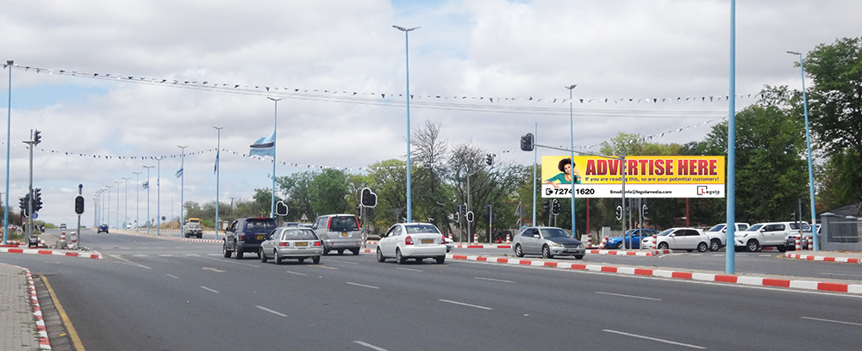
(for visual purposes only)
3m x 12m Billboard
Location: Major junction at Cnr Haskins/ Guy St, after the Police Station.
(For visual purposes only)
Media: Quantity 1, Size 3m x 12m (Flexi-face)
Media Costs: Inquire within for Monthly Rates, Production, Flighting costs and Availability.

