
KAZUNGULA Along highway to Kasane. 200m before Borogo Mall. North bound

BILLBOARD MEDIA
PROFILE

SITE REF: KAZ 1A
Plot 22995 Nkoyaphiri Industrial, Mogoditshane.
PO Box 1101, Gaborone
Tel: 392 4216 Mobile: 72 741 620
Email: info@legolamedia.com
www.legolamedia.com

3m x 6m Billboard

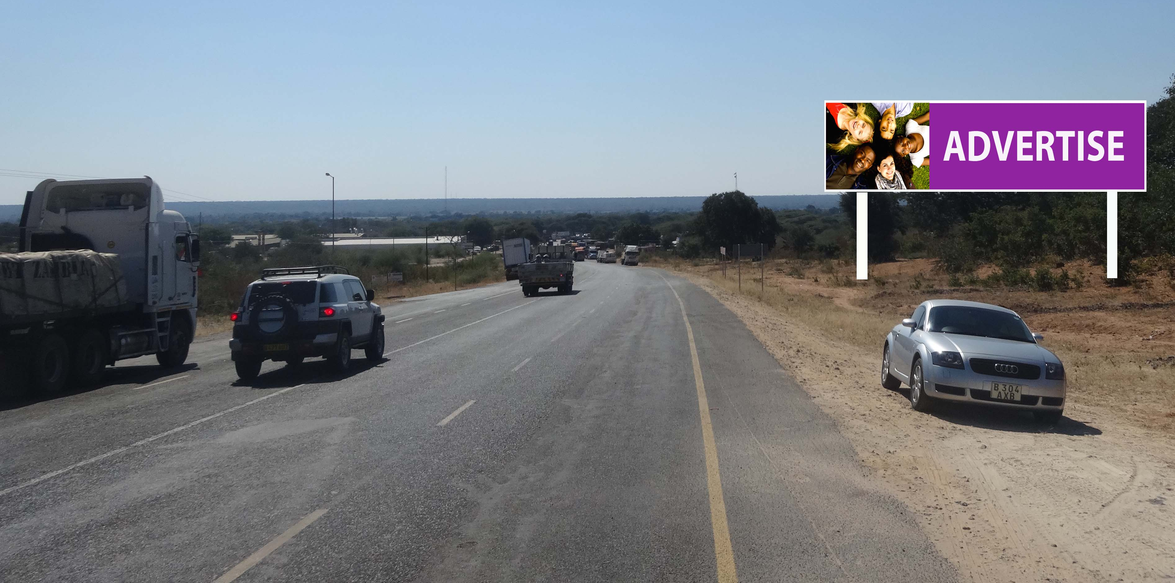
(for visual purposes only)
Location: Kazangula. Entering Kasane. Towards BDF, Engen Garage.
Media: Quantity 1, Size 3m x 12m (Flexi-face)
Media Costs: Inquire within for Monthly Rates, Production, Flighting costs and Availability.



